Implementation of Information Retrieval Models



Session: 2021 – 2025

# Submitted By:

Huzaifa Mumtaz 2021-CS-164

# Supervised By:

Dr. Khaldoon Syed Khurshid

Department of Computer Science

University of Engineering and Technology Lahore Pakistan

Introduction 3

Binary Independence Model 3

Non-Overlapping List Model 4

Proximal Nodes Model 4

Purpose of Assignment 4

Background 6

Binary Independence Model 6

Non-Overlapped List Model 6

Proximal Nodes Model 6

Implementation 7

Implementation Approach 7

Helper Functions 7

Results/Output 8

Binary Independence Model 8

Non-Overlapped List Model 8

Proximal Nodes Model 8

Conclusion 9

# Introduction

## Binary Independence Model

The Binary Independence Model (BIM) is a basic model used in information retrieval to determine the relevance of documents to a given query. It works by treating the presence or absence of terms in documents as binary features and calculates a relevance score based on the occurrence of these terms. This approach assumes that the terms in the documents are independent of each other. The BIM ranks documents based on their scores, allowing users to find the most relevant documents for their query.

In this assignment, the BIM is implemented to process a collection of documents and identify which ones are most relevant based on user input. The model leverages the presence of query terms within each document to calculate scores and rank the documents accordingly.

## Non-Overlapping List Model

The Non-Overlapped List Model is an information retrieval approach used to identify documents that contain specific query terms without any overlap between the terms themselves. In this model, each document is examined to check if it includes any of the given terms, and relevant documents are selected based on the presence of these terms. The model operates on the principle that documents with at least one matching term are considered relevant. This approach is simple and effective for retrieving documents that have a clear connection to the query terms, making it useful for scenarios where finding documents with specific keywords is the primary objective.

In this assignment, the Non-Overlapped List Model has been implemented to process a set of documents and identify which ones contain the terms specified by the user. This model returns a list of relevant documents, providing a straightforward way of retrieving information based on user-defined keywords.

## Proximal Nodes Model

The Proximal Nodes Model is an advanced information retrieval technique that focuses on identifying documents based on their relationships within a network or graph. This model operates by defining "proximal nodes," which are entities related to the desired information. The network or graph represents documents as nodes, and edges between them indicate connections or relationships. The goal of the Proximal Nodes Model is to explore these relationships to find documents connected to the defined proximal nodes.

In this assignment, the Proximal Nodes Model has been implemented to analyze a network of documents and determine which ones are connected to the user-defined proximal nodes. This model does not require the user to specify a proximity distance, simplifying the process. It retrieves documents that are directly connected to the defined nodes, allowing for more contextually relevant information retrieval based on the relationships between terms and documents.

## Purpose of Assignment

The purpose of this assignment is to implement and evaluate three different information retrieval models: the Binary Independence Model (BIM), the Non-Overlapped List Model, and the Proximal Nodes Model. Each model offers a unique approach to retrieving relevant documents based on user-defined queries. By developing and testing these models, the assignment aims to enhance understanding of various document retrieval techniques and their applications. The goal is to demonstrate how each model processes document content, retrieves relevant results, and presents them to the user, while exploring their strengths and limitations in different retrieval scenarios.

# Background

## Binary Independence Model

The Binary Independence Model (BIM) is a fundamental information retrieval model based on the probabilistic framework. It operates on the principle that each term's presence or absence in a document can be used to estimate the likelihood of the document being relevant to a given query. BIM assumes binary independence between terms, meaning the occurrence of one term does not affect the probability of the occurrence of another term in the document. This model is simple yet powerful for evaluating document relevance and is widely used in search engines and information retrieval systems. It uses the concept of term frequency and inverse document frequency (TF-IDF) for scoring documents based on their content similarity to a query.

## Non-Overlapped List Model

The Non-Overlapped List Model is a straightforward retrieval approach that focuses on finding documents containing specific terms provided by the user. This model operates by comparing a set of query terms with the content of documents to identify matches. Documents that contain any of the specified terms are selected as relevant. The Non-Overlapped List Model is useful when the goal is to filter documents that mention particular concepts or keywords, regardless of their frequency or contextual relationships. This method is efficient for use cases where users need basic term-based matching and quick retrieval without considering term proximity or complex relationships.

## Proximal Nodes Model

The Proximal Nodes Model leverages the concept of a graph or network structure to identify documents or nodes connected to specified entities. This model aims to find documents that are closely related to a given set of entities or keywords based on their connections in the network. The idea is to navigate through the graph and retrieve documents that share direct or proximate relationships with the identified nodes. This model is particularly effective for scenarios where contextual and semantic relationships between entities are important. For instance, in a collection of documents about space exploration, nodes such as "NASA," "astronauts," and "space missions" might be used to locate documents related to the topic. The Proximal Nodes Model enhances document retrieval by incorporating the interconnected nature of information, offering a deeper level of understanding and relevance in search results.

# Implementation

The implementation of this assignment involved developing three different information retrieval models: Binary Independence Model (BIM), Non-Overlapped List Model, and Proximal Nodes Model. Each model was designed to process a collection of text documents stored in a specified folder, allowing the user to query the documents and retrieve relevant results.

## Implementation Approach

* **Document Reading:** A function was created to read and store the content and name of all text documents from a given folder
* **User Interface:** The code included a simple text-based interface for the user to choose a model and enter query data.
* **Output:** Relevant documents were printed to the console based on the chosen model's retrieval process.

## Helper Functions

* **Helper Functions**: Functions for tokenization, string filtering, and document reading.
* **Main Logic**: A main function that allowed users to select and run each model, input queries, and display the output.
* **Error Handling**: Basic error handling was included to ensure that files could be read properly and results were generated as expected.

# Results/Output

## Binary Independence Model

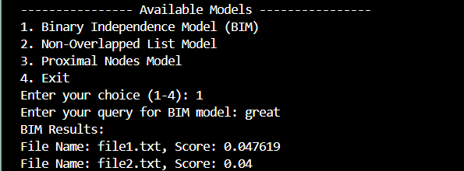

## Non-Overlapped List Model

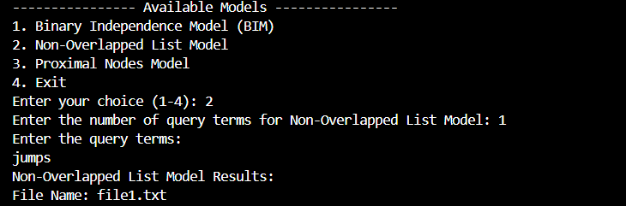

## Proximal Nodes Model

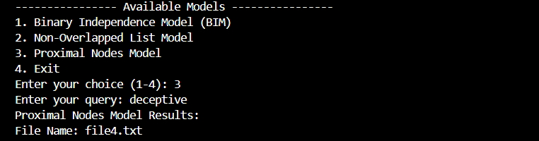

# Conclusion

This assignment successfully explored and implemented three distinct information retrieval models: the Binary Independence Model (BIM), the Non-Overlapped List Model, and the Proximal Nodes Model. Each model was designed to demonstrate a unique approach to retrieving relevant information from a collection of documents based on user queries.

* The **BIM** utilized statistical methods to calculate similarity between documents and the query, showcasing the effectiveness of probability-based retrieval techniques.
* The **Non-Overlapped List Model** provided a straightforward approach by retrieving documents that contained any of the query terms, emphasizing simplicity and directness in search.
* The **Proximal Nodes Model** leveraged graph-based relationships to uncover connections between query terms and documents, demonstrating the power of network-based information retrieval.

Through the implementation and testing of these models, the assignment highlighted the strengths and limitations of different retrieval techniques in varying contexts. This exercise enhanced the understanding of information retrieval systems, tokenization, similarity measurement, and graph traversal.

In conclusion, this assignment not only fulfilled its purpose of implementing the specified models but also provided valuable insights into designing efficient and effective retrieval systems for diverse applications.